**Login Page:**

**Admin Dashboard:**

* with clickable tiles landing on the pages with filtered content
* Calendar, that shows the hearing of cases(if any)

**Add Case Modal:  
**

**Cases:  
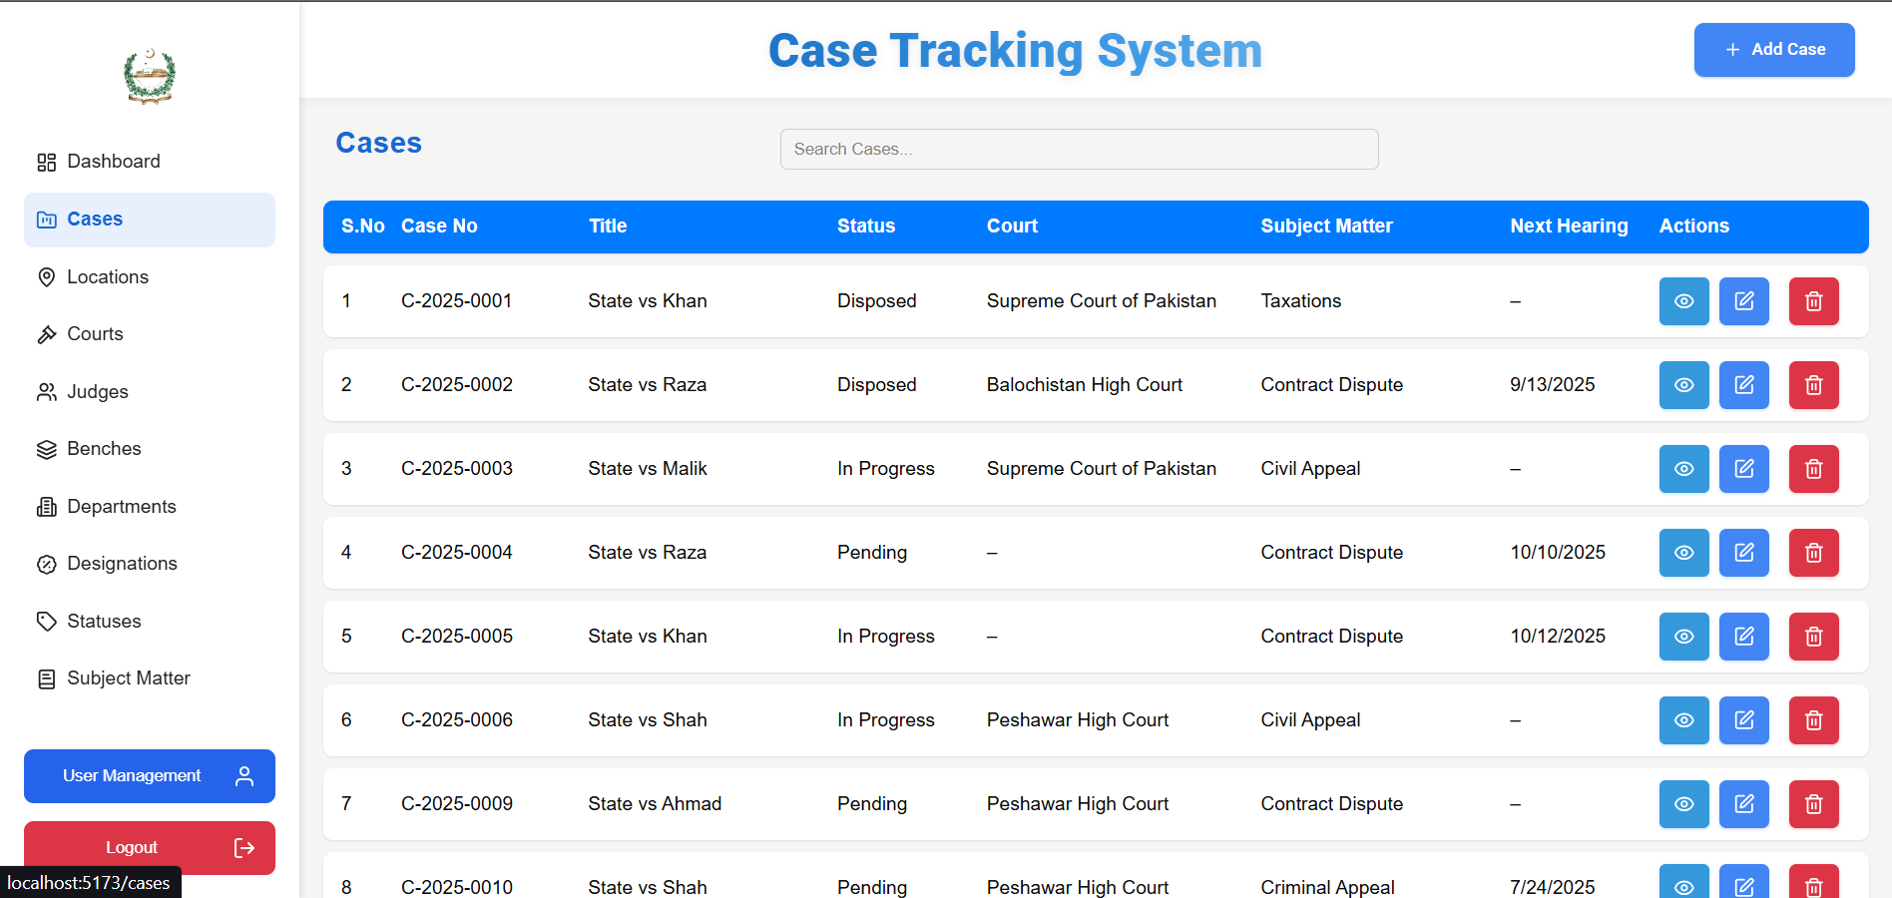**

**Case Summary (**using the Eye Button**):**

**Printable Report (**using the “Print” button in the Summary Screenshot above**):**

**Locations:  
  
**

**Add & Delete Locations:  
  
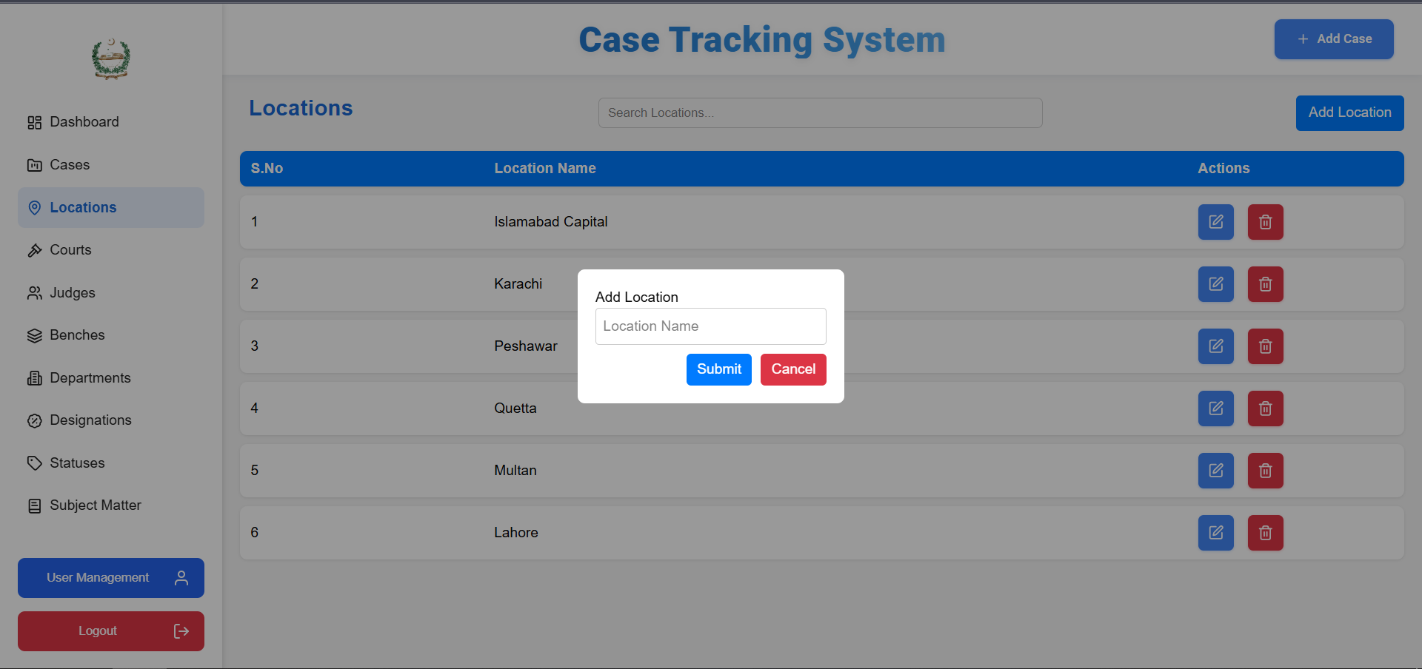**

**Courts:  
  
**

**Edit Courts:  
  
**

**Judges:**

**Edit Judge:**

**Benches:  
  
**

**Edit Benches:**

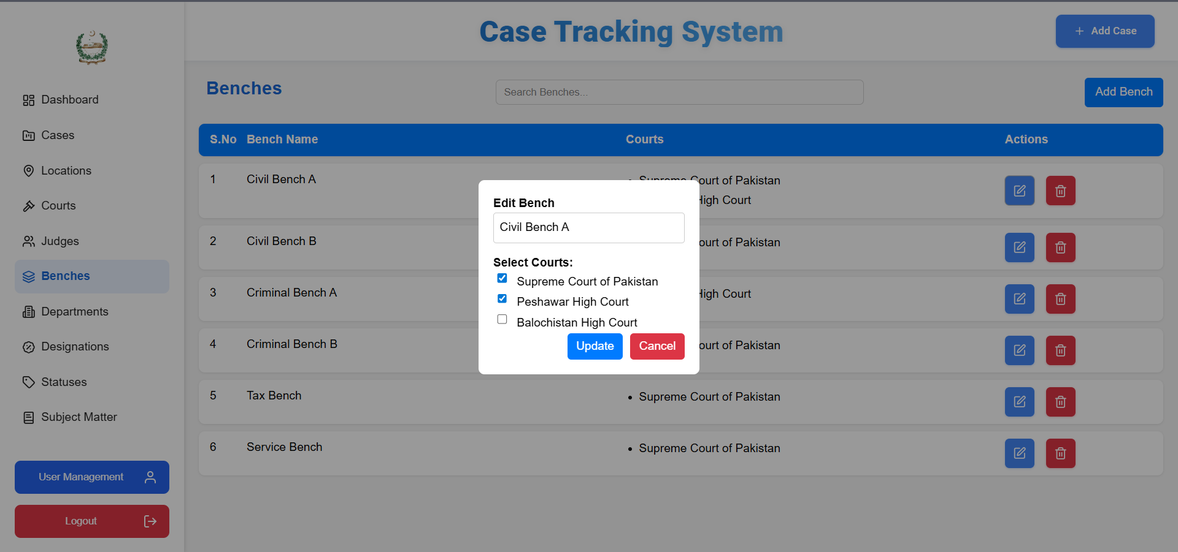

**Departments:  
  
**

**Edit Department:  
  
**

**Designations:**

**Edit Designation:  
  
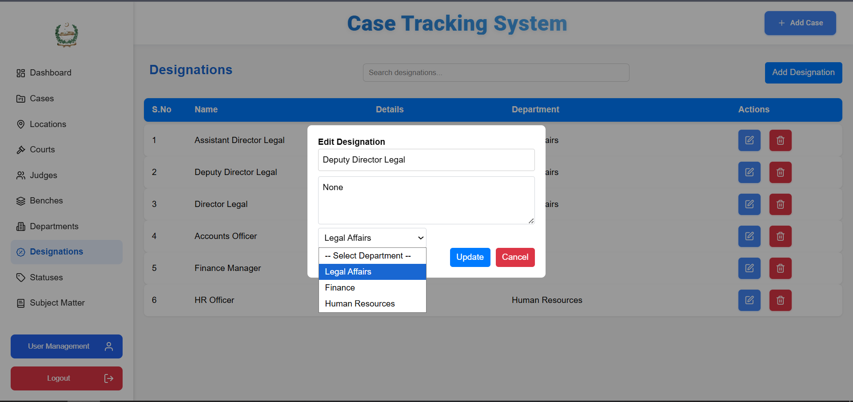**

**Statuses:  
  
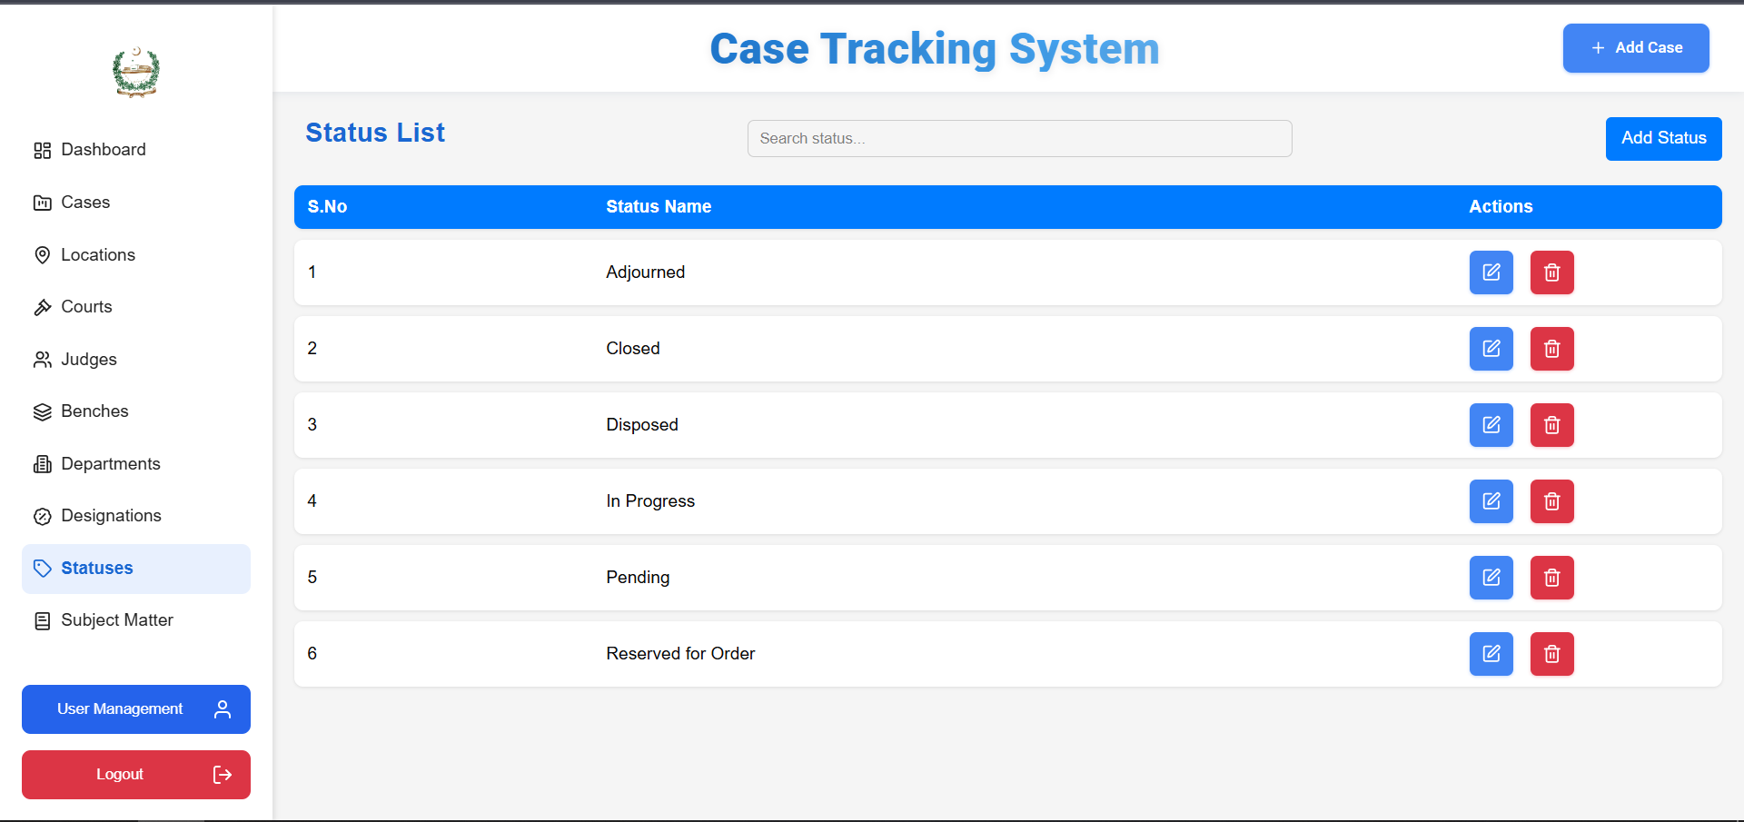**

**Subject Matters:  
  
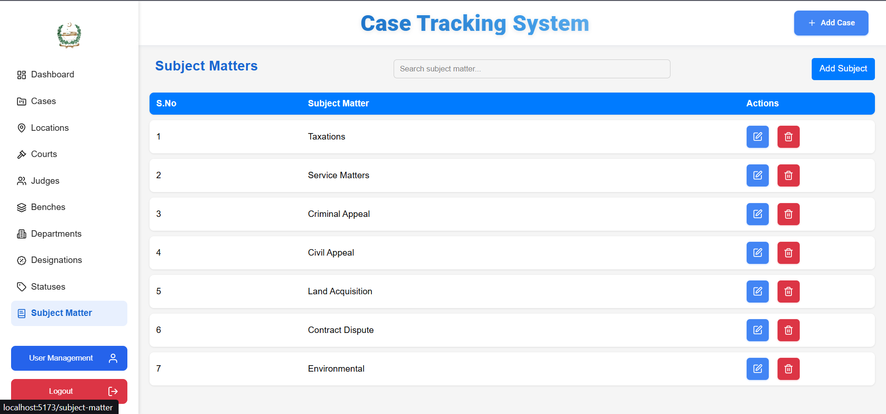**

**User Management Screen (**For Admin Only**):**

**Adding a User:  
  
**

**User(**With Read-only access**):**

* Cannot add, edit or delete any field

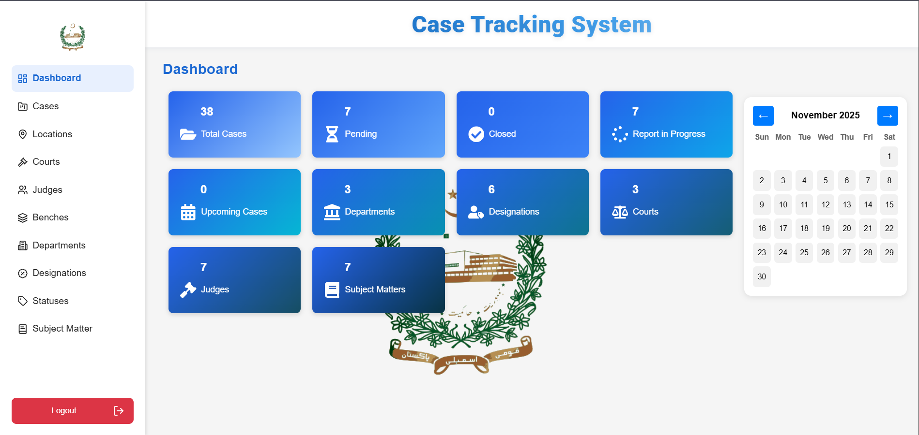

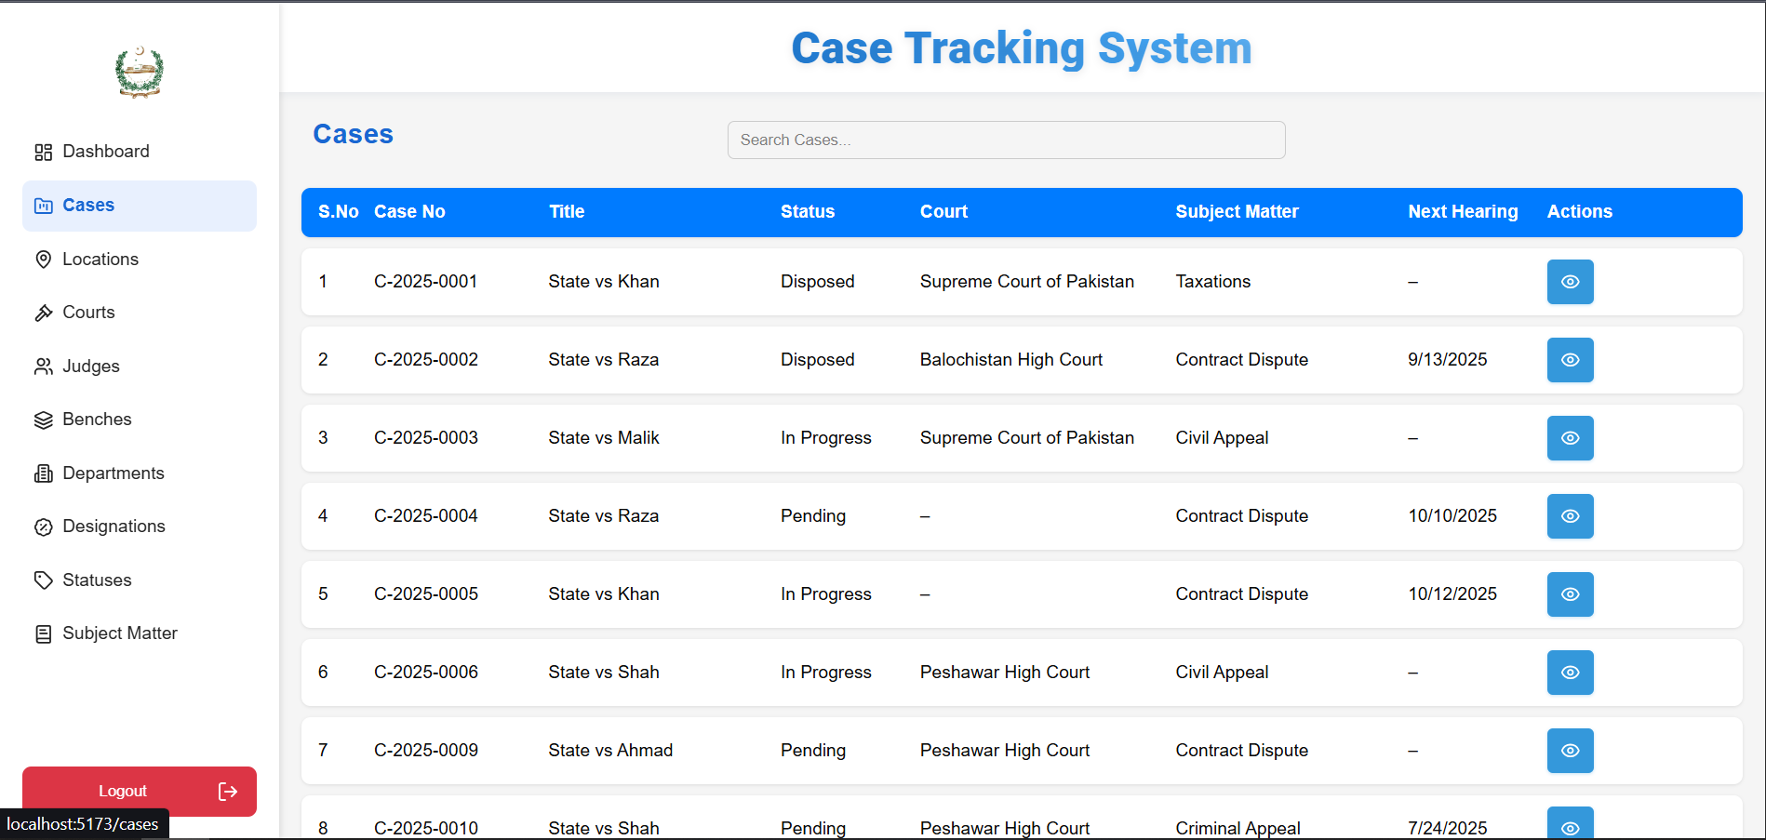

**Search-Bar to implement filtering/searching specific instances:  
  
**